EXPERIMENT 18 : PROLOG DATABASE WITH NAME AND DOB
QUESTION
Write a Prolog program to create a database containing names and dates of birth (DOB) and retrieve the information using queries.
AIM
To write and execute a Prolog program to create a database of names and dates of birth and retrieve the stored information.
PROCEDURE
- Start the SWISH Prolog editor.
- Define facts containing names and dates of birth.
- Create a rule to retrieve the name and DOB from the database.
- Enter the program into the editor.
- Run the program and execute the required queries.
- Display the retrieved information.
- Stop the program.
PROGRAM
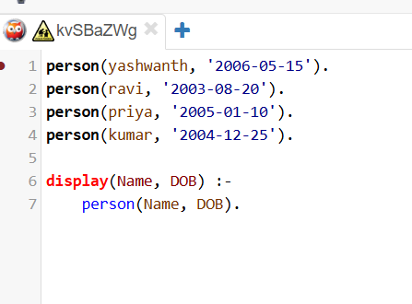

OUTPUT
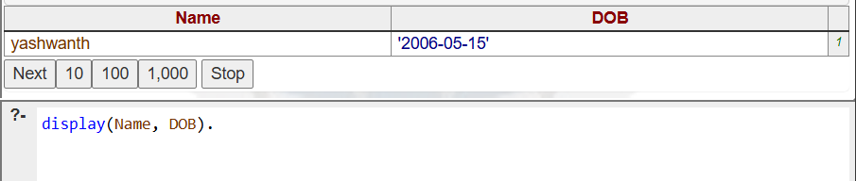

RESULT
Thus, the Prolog program to create a database containing names and dates of birth and retrieve the stored information was successfully executed.

